SQL ASSIGNMENTS-01
DDL Commands :
1. Table Creation (CREATE): Write the SQL statements to create a database named “employee” and the following tables based on the provided schema:
⦿ CREATE TABLE Departments
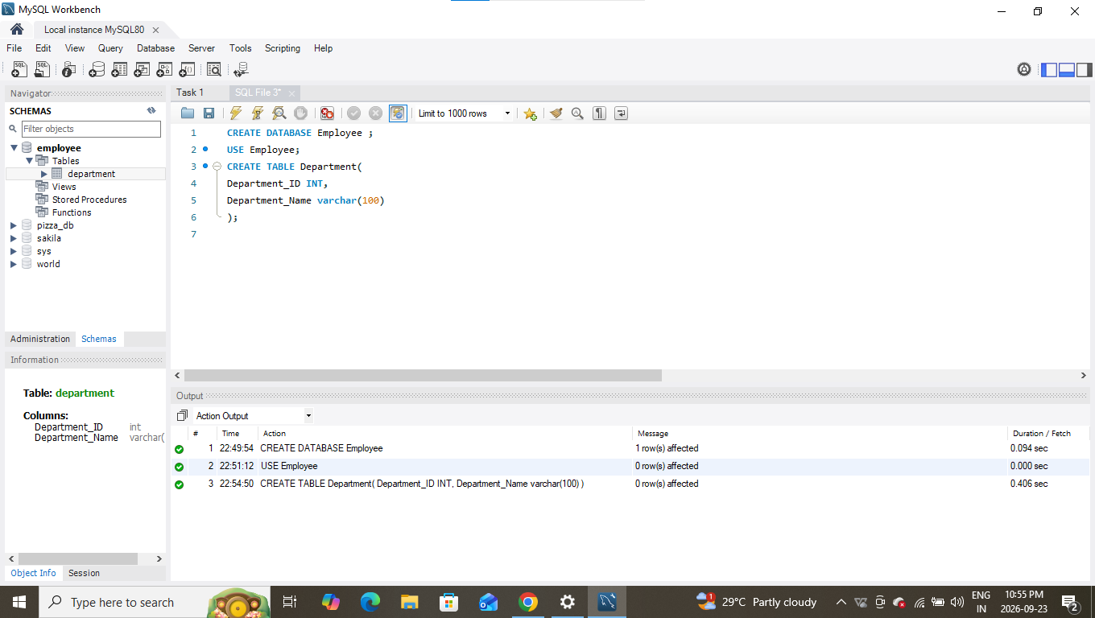
⦿ CREATE TABLE Location
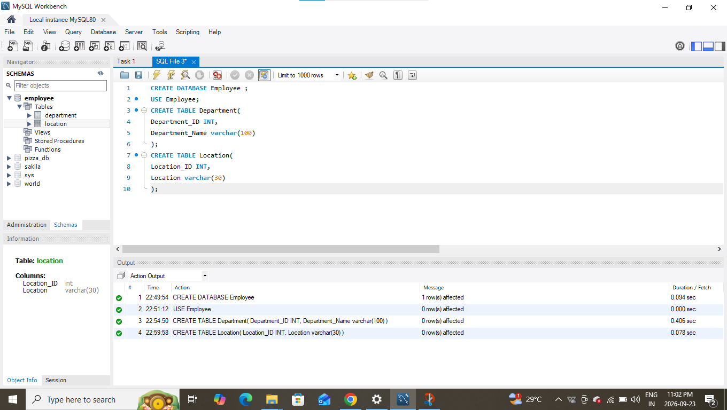
⦿ CREATE TABLE Employees
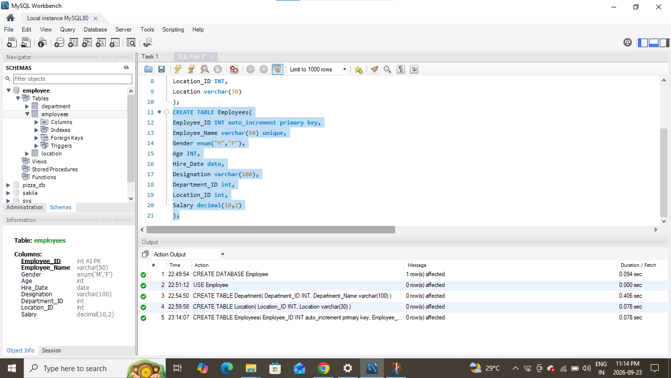
2. Table Alteration (ALTER): Consider the following scenarios and write the SQL statements to alter the structure of the tables accordingly:
⦿ Add a new column named "email" to the Employees table to store employee email addresses.
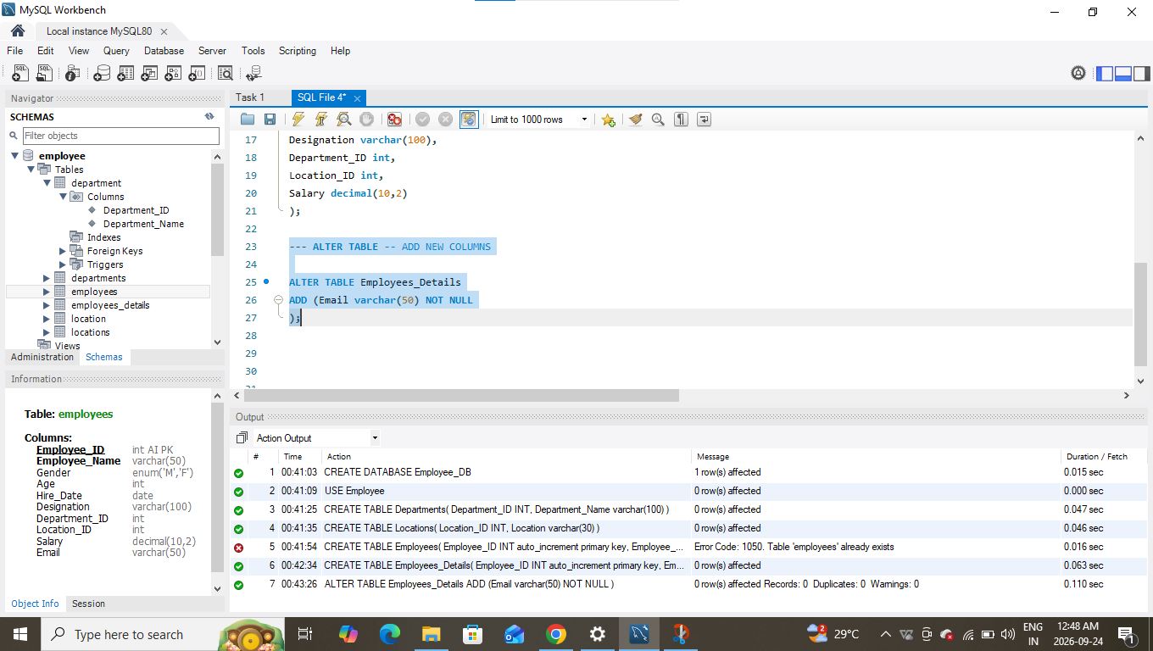
⦿ Modify the data type of the "designation" column in the Employees table to support a wider range of values.
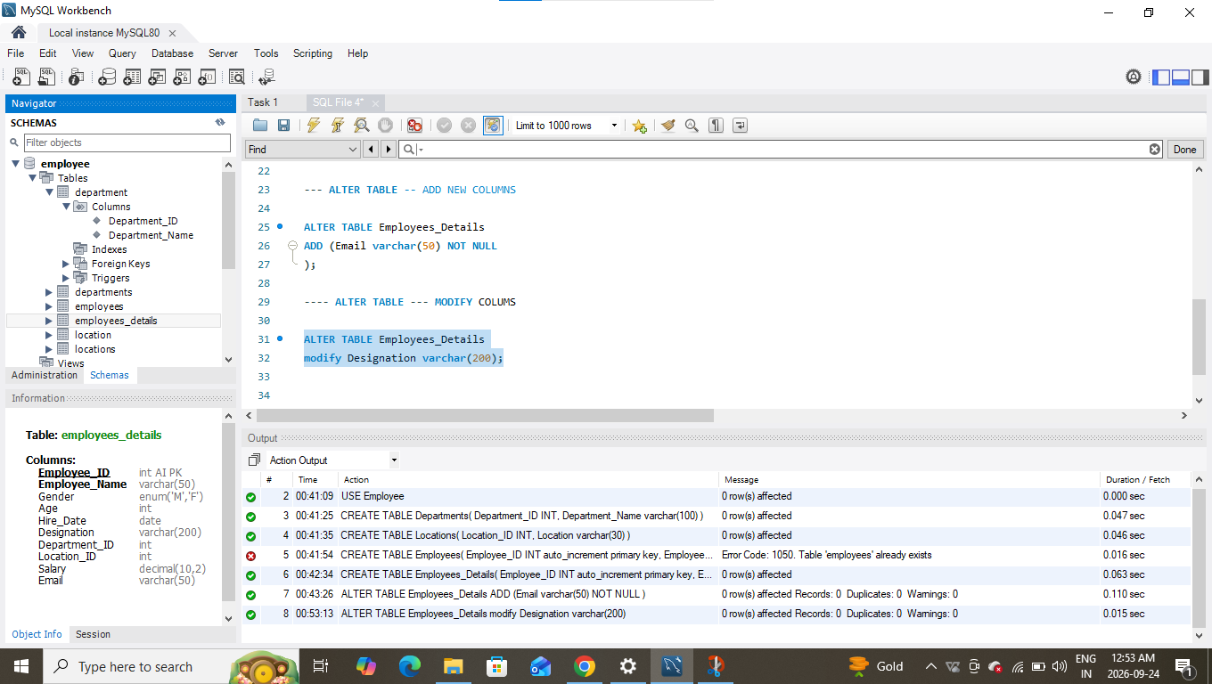
⦿ Drop the “age” column from the Employees table.
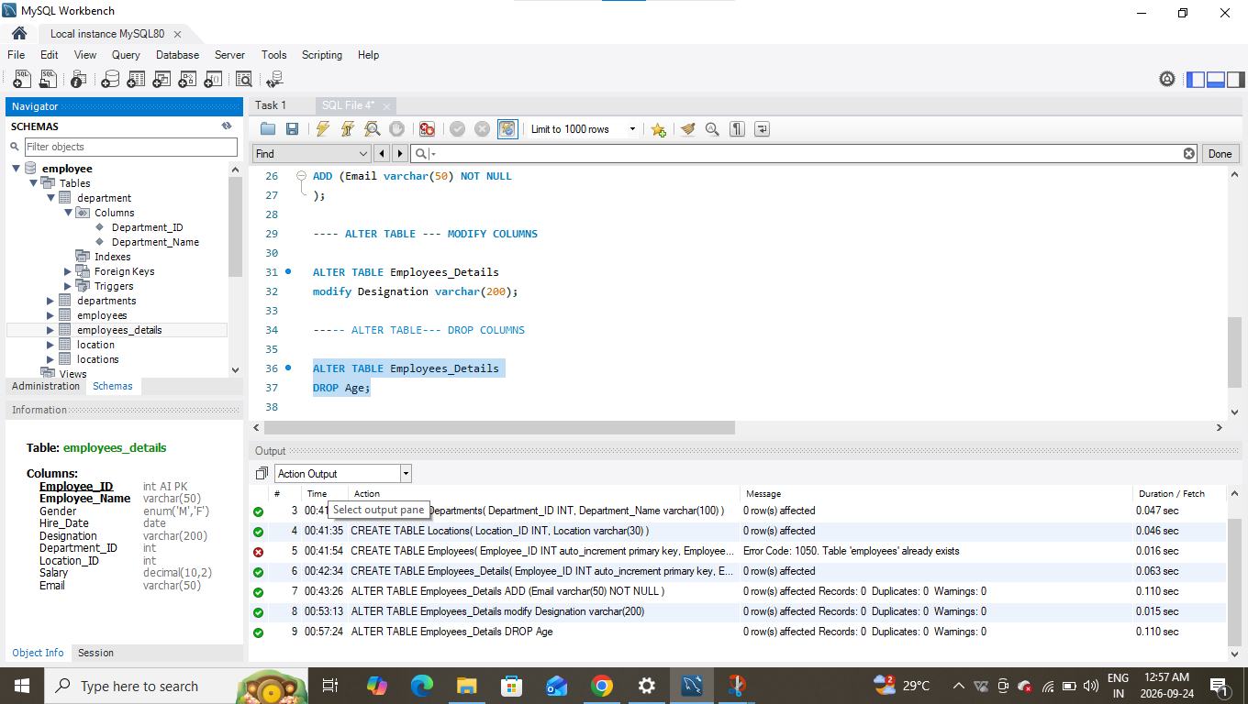

⦿ Rename the “hire_date” column to “date_of_joining”.
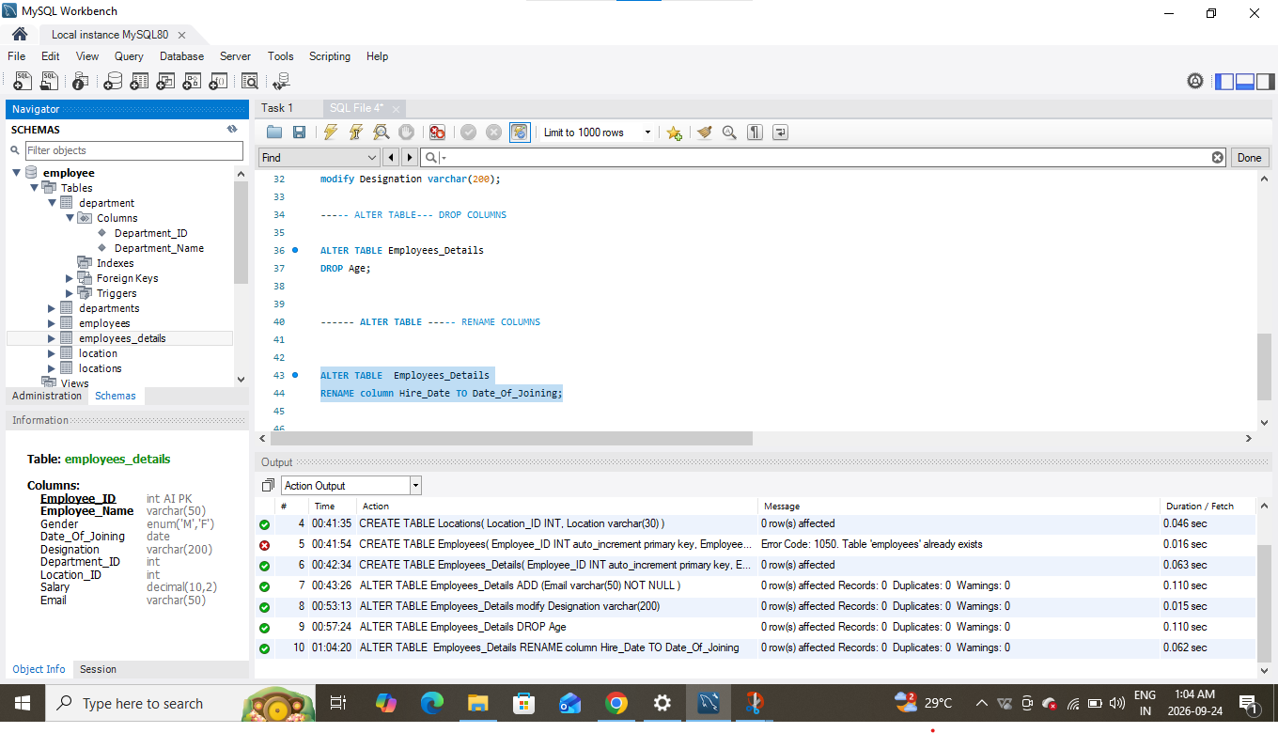
3. Table Renaming (RENAME): Rewrite the SQL statements to rename the following tables:
⦿ Rename the "Departments" table to "Departments_Info".
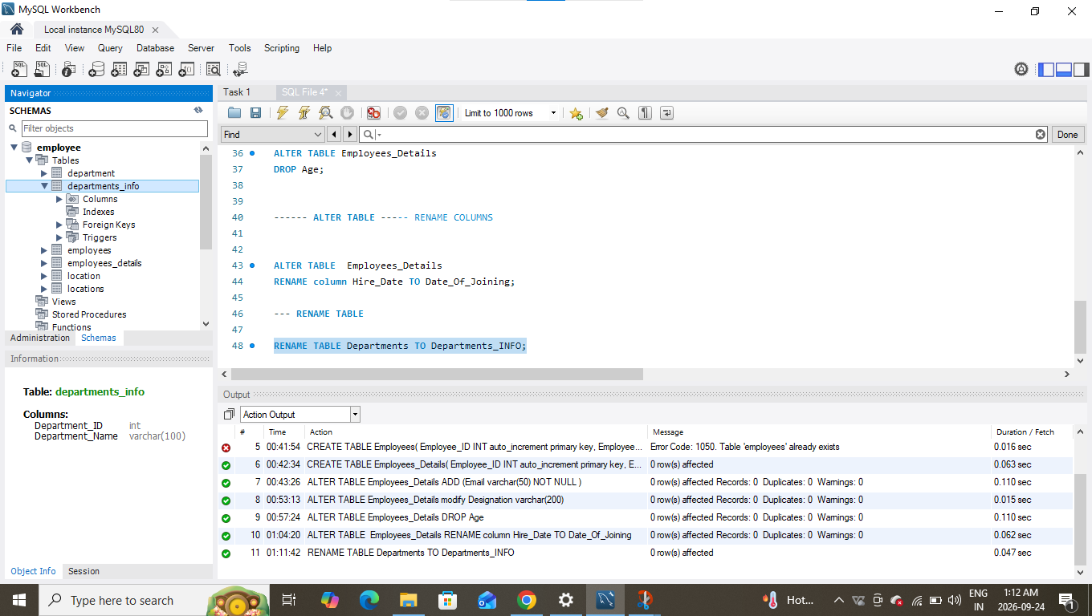
⦿ Rename the "Location" table to "Locations".
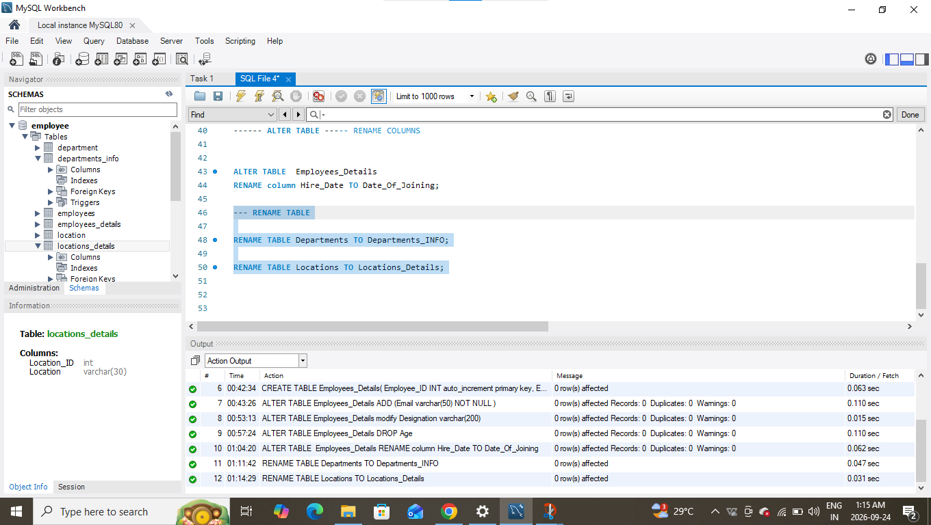
4. Table Truncation (TRUNCATE): Write an SQL statement to truncate the Employees table.
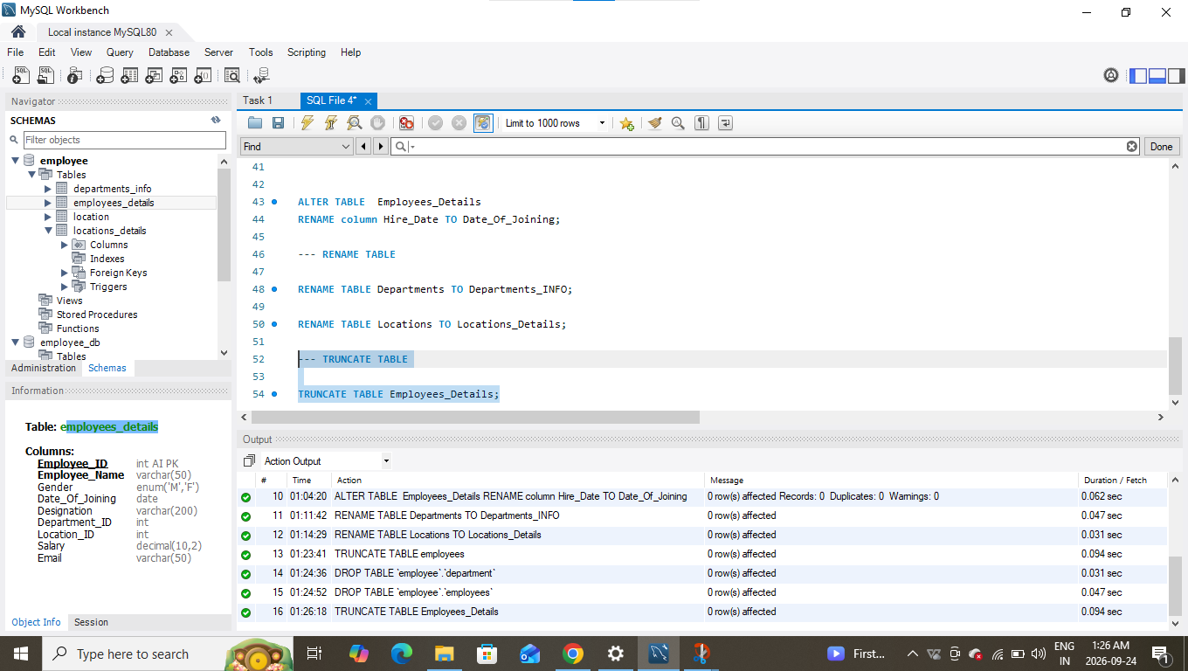
5. Database & Table Dropping (DROP): Write the SQL statements to drop the Employees table and then the “employee” database.
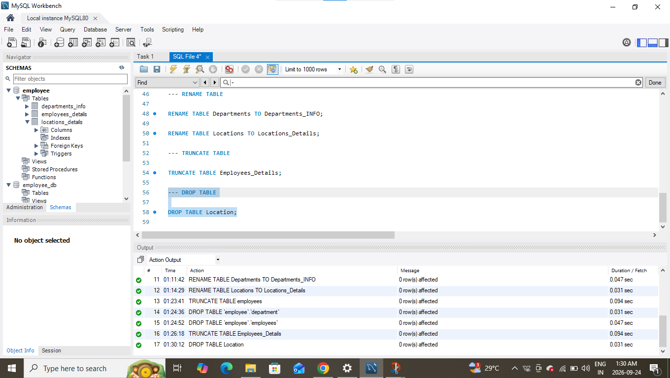
INSERT DEPARTMENT TABLE: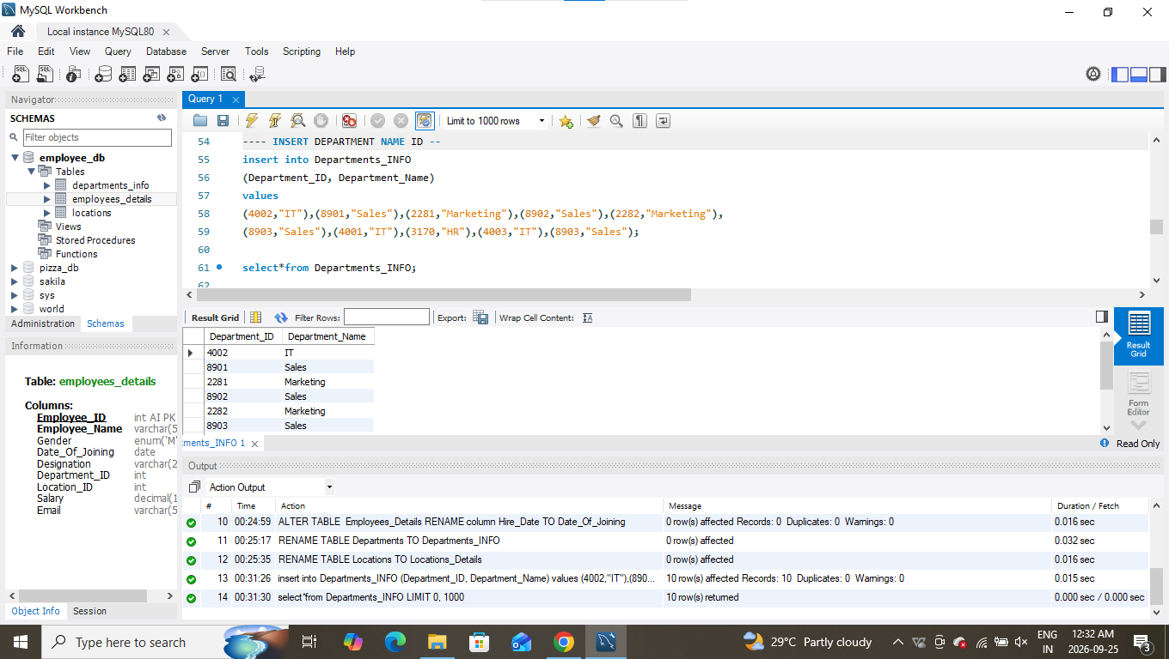

INSERT LOCATION TABLE
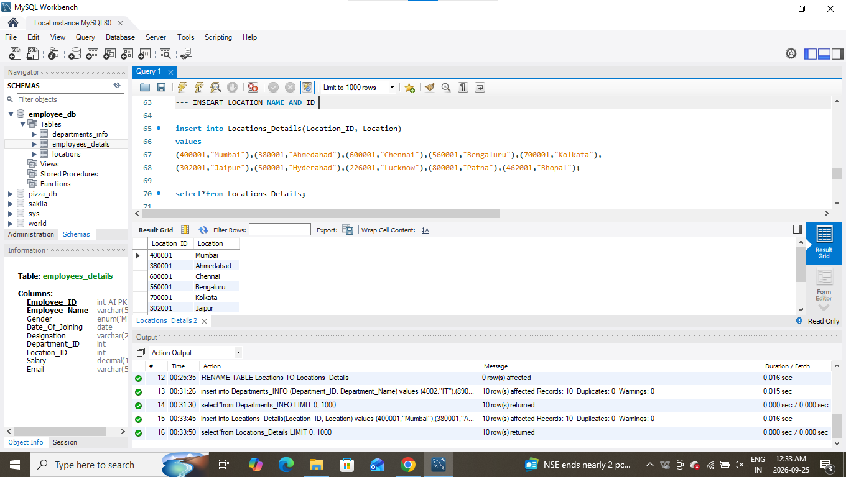
INSERT Employees TABLE
